I need your help!
I want to make a work of art that symbolises worldwide financial connections.
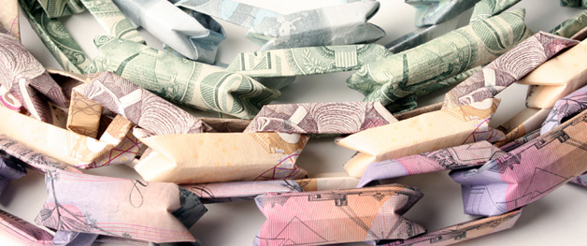
The last few years I have been making jewellery and objects from banknotes from all over the world. I started this to comment on the perceived value of gold jewellery and of money. It has made me curious to find out more about money and how it plays a role in our daily lives, and in international connections.
In these financially difficult times all sorts of questions arise about money. What is the value of different currencies? How safe is it to invest in gold versus currencies? How do money and debt influence our daily lives? I do not want to become a financial expert, but want to find out more about our human approach to money, what we do with it, and how we feel about it.
There is a tension between the financial destruction that takes place because of financial trading by investors on the one hand, and on the other hand amazing international solidarity when we donate money to people in need wherever they may be (for example the famine in Africa or the tsunami in Japan).
I would like to symbolise this duality by making a cloak. A cloak is the most basic piece of clothing to protect us from the harshness of our environment. It could symbolise the hiding of things we do not want to be revealed. But it can also keep us warm, we can shelter under it together.
This cloak is made from banknotes from all over the world. I want to use as many different notes as possible, from as many different countries as possible. I only want to use real money that is valid now. In other words: if you would unfold the jewellery you could take the banknotes to the shops, and pay for your goods. This is important, because I want the piece to have a real material value as well as a symbolic meaning. I need enough banknotes to cover a body, this will be an estimated 5500 banknotes.
The cloak can only be made through international collaboration. You can be a part of this project by sending me a banknote. I will link together all donated banknotes, and through them all comments and opinions collected from you, the participants, to create a piece that unifies us all in our concerns about money and the desire to make life better.
Only if we all work together will this piece become reality!
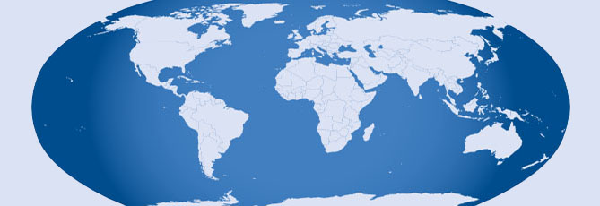
Please send me a banknote! Print off the second page of this document, fill it in and send it to me with your banknote. This information will feed into the investigation into how we perceive money and on the value of different currencies. It will be part of a publication to go with the cape when it is finished.
I will report on your contributions, my discoveries and progress on the project on my website.
If you want me to, I will mention your name on the project page of my website and in the publication that I will put together at the completion of this project.
Any profits arising from this project will be given to charity. Suggestions for a suitable cause are welcome.
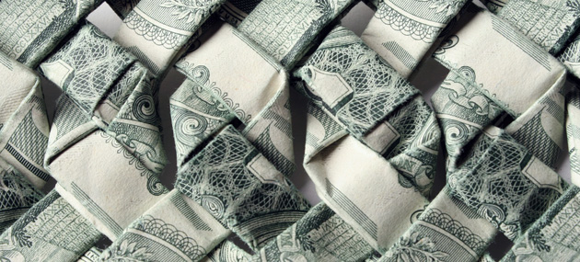
Many Thanks for your support!
Tine De Ruysser

Please fill in this leaflet and send it with your banknote to:

Tine De Ruysser
45 Watford Close
London
SW11 4QS
UK

Date
First Name
Surname
May I use your name for publication? (yes or no)
The Country where you live
Which Country does the banknote come from?
What is the name of this banknote?
For example:
1 Dollar, 10 Rand or 1 Ngultrum.
Is there anything you want to tell me about this banknote?
For example:
What can you buy with this one note?
Why do you want to give it to me?
What does money mean to you?
Anything else?
Continue on reverse if needed.
If you want to be kept informed, please give me your email address (in capital letters).
I will never pass this information on to anyone.

I am collecting this information to learn more about money and how we perceive it.
I will treat all your personal information as confidential.
I will never reveal your email address to anyone. I will only use it to keep you informed about progress on this project.
If you would like me to, I will mention your name on my website as one of the supporters of this project. If you do not want your name published, I will keep it a secret only for me to know.
Thank you!
Tine De Ruysser

